Visualization Report

Name : Vineeth Kumar Naredla  
ID : 22091863

GITHUB : <https://github.com/vineeth7858/Visualisation-Assignment-1>

## Visualization-1: Average monthly temperature of 4 cities over last two years

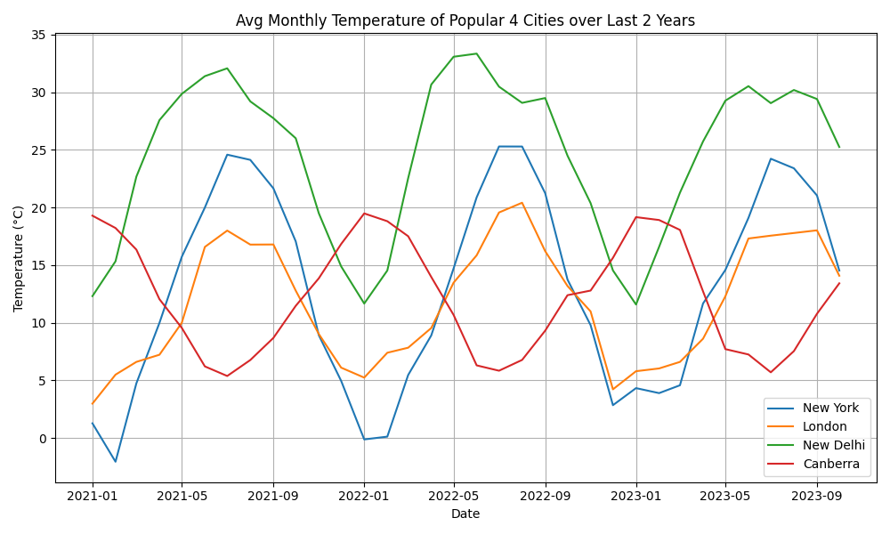

Source: <https://open-meteo.com/en/docs/historical-weather-api>

A line chart is better for this data because it shows the trend of the average monthly temperature of four popular cities over the last two years. A line chart can easily display the fluctuations of the temperature over time for each city, as well as the comparison between the cities.

The average monthly temperature of New York, London, New Delhi and Canberra varies over the last two years, with New Delhi having the highest temperature and New York having the lowest temperature. The chart shows that New Delhi, New York and London follow a similar seasonal pattern, with the temperature peaking in May, June and July and dropping in December and January. London has a similar pattern, but with a lower range of temperature. New York has a more irregular pattern, with some spikes and dips throughout the year. Canberra has an opposite pattern to New Delhi, with the temperature reaching its lowest in June and July and its highest in December and January. The chart also shows that the temperature difference between the cities is larger in the winter months than in the summer months.

## Visualization -2: Number of movies and tv shows released each year from 2000

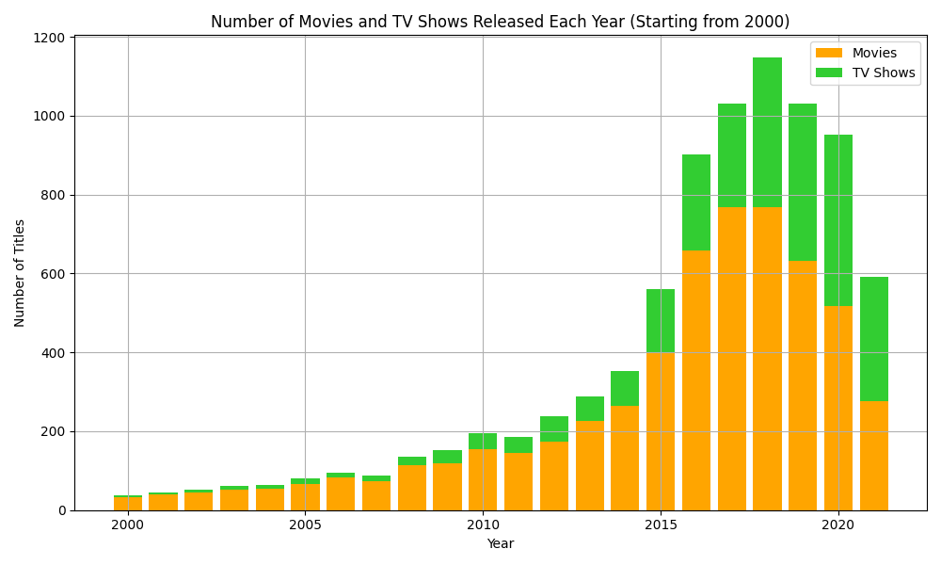

Source: <https://www.kaggle.com/datasets/shivamb/netflix-shows>

A stacked bar is a clear visual representation of the total number of movies and TV shows released each year, while also illustrating the proportion of each category. This visualization method effectively conveys trends over time, highlighting the overall growth in releases and the shifting balance between movies and TV shows.

The chart depicts the annual release count of movies and TV shows from 2000 to 2020. Notably, 2018 marked the peak year with over 1100 titles, contrasting with the lowest point in 2000 when less than 100 titles were released. Throughout the period, movies consistently outnumbered TV shows, although a noticeable surge in TV show releases has been evident since 2016, indicating a changing landscape in the entertainment industry.

## Visualization-3: Smartphone usage of male’s vs females between 2019 and 2020

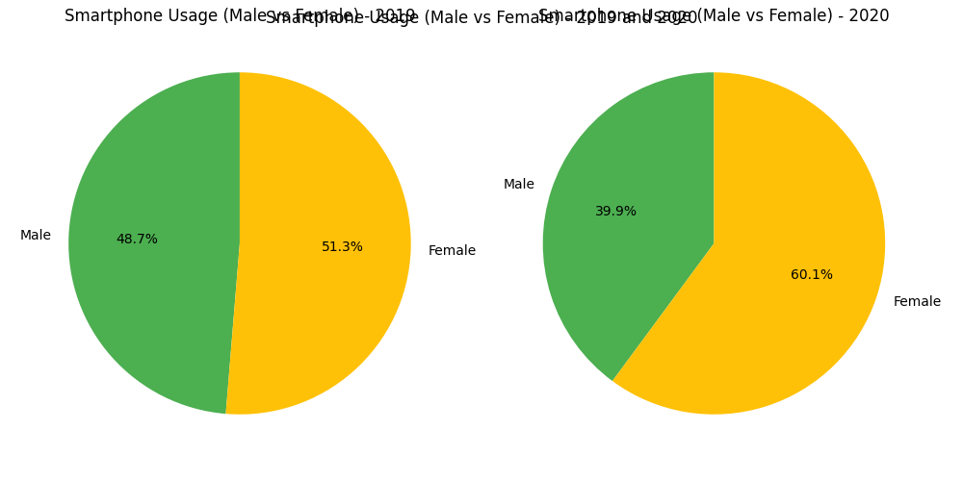

Source: <https://www.mdpi.com/2227-9709/9/4/98#app1-informatics-09-00098>

The Pie chart is a good way to represent percentages of a whole. The plot shows the percentage of smartphone usage by males and females between 2019 and 2020.

The chart shows that in 2019, females use smartphones slightly more than males, with 51.3% and 48.7% respectively. Similarly, females use smartphones significantly more than males, with 60.1% and 39.9% respectively. The chart reveals that females spend more time on smartphones then their counterparts in both the years.